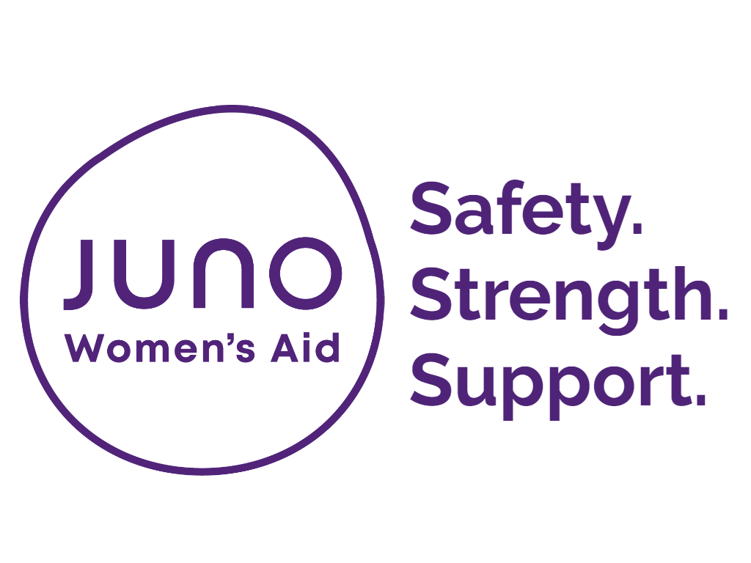

Juno Women’s Aid
City Teen Advocate Services

How to complete this referral:
By completing this referral form, you’re helping us to make contact with the family/teenager as safely and quickly as possible. We’d appreciate it if you could include as much information as this saves the family/teenager from being asked the same questions twice and helps us to understand more about their particular needs and circumstances.
If you have any questions please contact Teen Advocate Duty Desk on: 0115 8221760, Monday – Thursday 9.00am – 5.00pm

How to submit this referral:

To submit your referral by email please ring beforehand for the password to protect your referral documents:
Email: samc@junowomensaid.org.uk
Alternatively you can post or fax your referral to: | City Teen Advocate Service  Juno Women`s Aid  30 Chaucer Street  Nottingham  NG1 5LP  Fax: 0115 9472199
Eligibility Criteria:

The YPVA service offers specialist support to teenagers from an accredited practitioner, focusing on those who have experienced domestic abuse in their own intimate relationship, in addition responding to other areas of violence against young women and girls both practical and emotional. The criteria’s for support into the service are below:
- Female Teens in intimate relationships aged 13-17years old (18 year olds with a learning disability)
- Female to Female violence aged 13-17
- Child sexual exploitation
- Gang related issues
- Sexting, stalking and harassment
- Youth offending linked to Domestic Abuse
- Honour based violence
- Forced Marriage
- Online Grooming

We provide partnership working to; Domestic Abuse Support Unit, HBV and Force Marriage unit, Equation, YOTs, Beckhampton Teenage project, The DART, Social Care, Targeted support, Teenage Midwife Team, Family Nurse Partnership alongside and schools.
When we will respond:

The City Team will aim to respond to your referral within 2 working days.

- Information about the person making the referral
Date of referral: | Click here to enter text.
Please indicate which service you’d like to refer to:
Click here to enter text.

Please enter your name and contact details:
Referrer’s name | Click here to enter text.
Organisation name | Click here to enter text.
Role/ job title | Click here to enter text.
Contact number | Click here to enter text.
Contact email | Click here to enter text.
Consent:
Has the Child/teen given consent to have the referral? |  | ☐ Yes ☐ No ☐ Don’t Know

2. Child/Teenagers contact information
Names
First name |  | Click here to enter text.
Last name |  | Click here to enter text.
Other names |  | Click here to enter text.
What do they like to be called? |  | Click here to enter text.
Date of Birth |  | Click here to enter text.
Contact info for this referral
Please contact: |  | ☐ Child or teenager directly  ☐ Parent/ Carer
Details Safe to contact?
Phone |  | Click here to enter text. |  |  |  |  | ☐ to call  ☐ to text  ☐ to leave voicemail
Email |  | Click here to enter text. |  |  |  |  | ☐
Current address  (inc. postcode) |  | Click here to enter text. |  |  |  |  | ☐ to post
Safe contact notes |  | Click here to enter text.
Safe Alternative contact number
Name |  | Click here to enter text.
Relationship to YP |  | Click here to enter text.
Details Safe to contact?
Phone |  | Click here to enter text. |  |  |  |  | ☐ to call  ☐ to text  ☐ to leave voicemail
Email |  | Click here to enter text. |  |  |  |  | ☐
Current address  (inc. postcode) |  | Click here to enter text. |  |  |  |  | ☐ to post
Safe contact notes |  | Click here to enter text.
Next of kin – who can we contact in an emergency?
Name |  | Click here to enter text. |  |  | Relationship |  |  | Click here to enter text.
Contact information |  | Click here to enter text.
Safe contact notes |  | Click here to enter text.
Perpetrators Details
Name |  |  |  |  |  | Relationship
D.O.B
Contact Information
School/ college/ Training info for YP:
Click here to enter text.

Safeguarding
Are children’s services involved with YP |  |  | ☐ Yes ☐ No ☐ Don’t Know
Level/ nature of involvement – notes: |  |  | Click here to enter text.
Access requirements
Does this teen have any access requirements (for example, braille documents) |  |  | ☐ Yes  ☐ No  ☐ Don’t Know | If yes, please provide details:  Click here to enter text.
Do they have any allergies? |  |  | ☐ Yes  ☐ No  ☐ Don’t Know | If yes, please provide details:  Click here to enter text.
Does this child/teen require an interpreter? |  |  | ☐ Yes  ☐ No  ☐ Don’t Know | If yes, please provide details:  Click here to enter text.

- Teenagers equalities monitoring
How would this child/teen describe their gender? | ☐ Female  ☐ Male  ☐ Other (please specify): Click here to enter text.  ☐ Don’t Know
Is their current gender different to the sex they were assigned at birth? | ☐ Yes  ☐ No  ☐ Don’t Know
The 2010 Equality Act defines disability as ‘a physical or mental impairment which has a substantial and long term adverse [negative] effect on their ability to carry out normal day to day activities’

Based on the definition above, do they consider themselves to have any kind of disability?  (please tick any that apply) | ☐ Physical  ☐ Learning  ☐ Mental Health |  | ☐ Deaf/ hearing impaired  ☐ Blind/ visually impaired  ☐ Other (please specify):  Click here to enter text.  ☐ Don’t Know
How would they describe their ethnicity?
☐ White British  ☐ White Irish  ☐ White Gypsy or Irish Traveller  ☐ Any other White background  ☐ Asian British  ☐ Asian Indian  ☐ Asian Pakistani  ☐ Asian Bangladeshi  ☐ Any other Asian background  ☐ Chinese  ☐ Arab |  | ☐ White and Black Caribbean  ☐ White and Black African  ☐ White and Asian  ☐ Any other mixed/ multiple background  ☐ Black British  ☐ Black African  ☐ Black Caribbean  ☐ Any other Black background  ☐ Other (please specify):  Click here to enter text.  ☐ Don’t Know
Do they have a faith/ religion?
☐ No religion  ☐ Bahai  ☐ Buddhist  ☐ Christian  ☐ Hindu  ☐ Jewish  ☐ Jain |  | ☐ Muslim  ☐ Shinto  ☐ Sikh  ☐ Zoroastrian  ☐ Other (please specify):  Click here to enter text.  ☐ Don’t Know
What is their sexual orientation? (if age appropriate) | ☐ Heterosexual/ straight  ☐ Gay woman/ Lesbian  ☐ Gay man  ☐ Bisexual  ☐ Other (please specify): Click here to enter text.  ☐ Don’t Know

- Teenagers support needs/ vulnerabilities
Please tell us more about any support needs the child/teen may have:
☐ Mental Health  ☐ Physical Health  ☐ Sexual Health  ☐ Substance misuse  ☐ Aggressive behaviour  ☐ Self-harming/ suicidal feelings | ☐ Issues with educational attainment/ attendance  ☐ Social isolation  ☐ Bullying/ being bullied  ☐ Experiencing abuse  ☐ Other (please specify below)
Additional details:
Click here to enter text.

5. Services
Please provide details of any services involved with the YP
Agency Name | Contact Details
Click here to enter text. | Click here to enter text.
Click here to enter text. | Click here to enter text.
Click here to enter text. | Click here to enter text.
Click here to enter text. | Click here to enter text.
Click here to enter text. | Click here to enter text.
Click here to enter text. | Click here to enter text.

6. Reason for referral
Why are you making this referral – how could this child/teen benefit from our support?
Click here to enter text.

Are there any known risks to working with this child/teen?
Click here to enter text.
Are you including any of the following documents with your referral?
☐ CAF paperwork
☐ Teen /Adult DASH RIC
☐ Other (please specify): Click here to enter text.

Thanks for taking the time to complete this referral.

Before you send the referral, please check that your referral meets the criteria set out on the first page of this document, and that any relevant additional materials e.g. CAF, CSE assessment, Teen DASH RIC are attached. Please see coversheet for how to send this referral to the JUNO Teen Advocate Service.

OFFICE USE ONLY
Modus ID:
Referral outcome
Referral accepted? | ☐ Yes  ☐ No
Allocated to:
Please complete if the referral was rejected
Reason for rejection | ☐ Unable to contact  ☐ Client does not want support  ☐ No space/ capacity to support  ☐ Ineligible for support (age)  ☐ Ineligible for support (borough/district/authority)  ☐ Ineligible for support (service description)  ☐ Unable to meet support needs around language  ☐ Unable to meet support needs around large family  ☐ Unable to meet support needs around mental health  ☐ Unable to meet support needs around disability  ☐ Unable to meet support needs around No Recourse to  Public Funds  ☐ Unable to meet support needs around drug and alcohol  ☐ Previous convictions for violent/sexual offences/ arson  ☐ Other
Referred/ signposted on to: | ☐ Another refuge  ☐ Another specialist Violence Against Women and Girls  service  ☐ National Domestic Violence  ☐ Non-VAWG organisation/ service  ☐ Other

