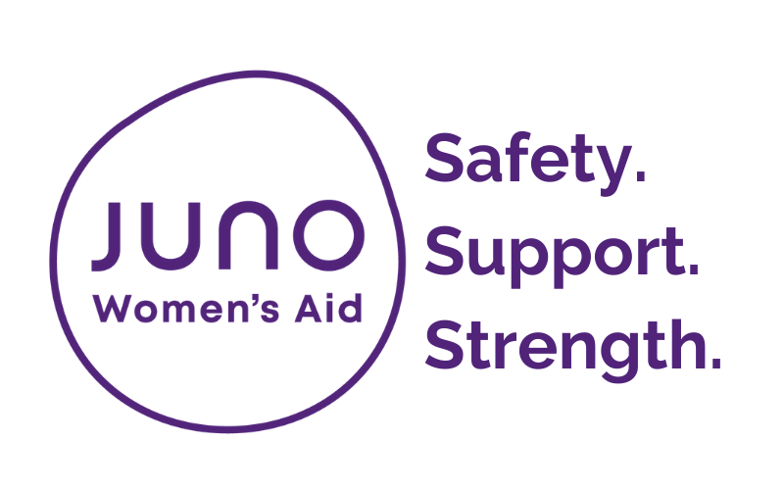

Juno Women’s Aid
Children and Teen Advocate Services

How to complete this referral:
By completing this referral form, you’re helping us to make contact with the family/teen as safely and quickly as possible. Please complete thoroughly as this saves the family from being asked the same questions twice and helps us to understand more about their particular needs and circumstances.
If you have any questions about a service please contact the service directly.
If your question is about a specific referral please contact the Referral Hub 0115 9475257 Monday-Friday 9am -5pm

How to submit this referral:
To submit your referral via unsecure email please use this password to protect your document:

#Emp0wer!

and email to:

Email: referrals@junowomensaid.org.uk
Nottingham City and South Nottinghamshire: Gedling, Broxtowe, Rushcliffe, Ashfield and, Eligibility Criteria:

Children and teenagers who have witnessed or experienced domestic violence and abuse from the south of the county (Ashfield, Broxtowe, Gedling or Rushcliffe) and Nottingham city

One to one support (County) /Young Voices project (City) :
- The child must be aged 5 – 17 years (School years 1 – 13)
- The child has witnessed and has a memory of domestic violence and abuse within the home
Other criteria:
- For the Young voices project (City), where the child or young person is still living with the perpetrator, an additional risk assessment will be carried out, to ensure the Young Voices service is appropriate for the individual.
Group Work (County):
- The child must be aged 5 – 16 years (School years 1 – 11)
- The child has witnessed and has a memory of the domestic violence and abuse within the home
Stronger families (City) :
- Stronger Families is group recovery programme for mothers and their children who have witnessed or experienced domestic violence and abuse and live within Nottingham City.
Other criteria:

- The abusive relationship has ended and the family are no longer living with the perpetrator.
- The child is at least 5 years old (school year 1) and has a memory of the abuse within the home.
- The family should no longer be in crisis.
- Referrers are able to support the family to ensure both mother and child attend their group sessions.
Teen Advocate Support:
- The teenager is aged 13-17 years (female and male) and has experienced abuse in their own intimate relationship

Family Court Support Service (County)
- Woman and child/ren (5-17) who are due to go through family and civil court proceedings where domestic abuse is a presenting or historical factor and where there are child arrangements proceedings
Knife Crime (City & County)
- Child/ren and young people (5-17) who are living with or have experienced domestic violence or abuse (DVA) where there has been a knife or weapon used in a domestic abuse incident by the perpetrator.
Escape The Trap (ETT County)
- This is a group work programme for young people age 13 -17 years old and is run within schools to educate and inform about abusive relationships and keeping safe. This cannot be directly referred into but you can indicate on the form if you think it would be useful for the young person.

Additional information to submit?

Early Help Assessment Form (EHAF), Teen DASH RIC and any other risk assessments that would support this referral.
When we will respond:

We will aim to respond to your referral within 2 working days.

- Information about the person making the referral
Date of referral: | Click here to enter text.
Please indicate which of the above services you’d like to refer to:
Click here to enter text.

Area:
☐ Nottingham City ☐ Nottinghamshire county ☐ Don’t Know
Please enter your name and contact details:
Referrer’s name | Click here to enter text.
Organisation name | Click here to enter text.
Role/ job title | Click here to enter text.
Contact number | Click here to enter text.
Contact email | Click here to enter text.
Consent:
Has the Child/teen given consent to have the referral? |  | ☐ Yes ☐ No ☐ Don’t Know

2. Child/Teenagers contact information
Names
First name | Click here to enter text.
Last name | Click here to enter text.
Other names | Click here to enter text.
What do they like to be called? | Click here to enter text.
Date of Birth | Click here to enter text.
Contact info for this referral
Please contact: | ☐ Child or teenager directly  ☐ Parent/ Carer
Details Safe to contact?
Phone | Click here to enter text. |  |  |  | ☐ to call  ☐ to text  ☐ to leave voicemail
Email | Click here to enter text. |  |  |  | ☐
Current address  (inc. postcode) | Click here to enter text. |  |  |  | ☐ to post
Safe contact notes | Click here to enter text.
Mother/ carer contact information
Mother/carer name | Click here to enter text.
Date of Birth | Click here to enter text.
Details Safe to contact?
Phone | Click here to enter text. |  |  |  | ☐ to call  ☐ to text  ☐ to leave voicemail
Email | Click here to enter text. |  |  |  | ☐
Current address  (inc. postcode) | Click here to enter text. |  |  |  | ☐ to post
Safe contact notes | Click here to enter text.
Next of kin – who can we contact in an emergency?
Name | Click here to enter text. |  |  | Relationship |  | Click here to enter text.
Contact information | Click here to enter text.
Safe contact notes | Click here to enter text.
Nursery/ School/ college/ info:
Click here to enter text.

Safeguarding
Are children’s services involved in this case? |  | ☐ Yes ☐ No ☐ Don’t Know
Level/ nature of involvement – notes: |  | Click here to enter text.
Access requirements
Does this child/ teen have any access requirements (for example, braille documents) |  | ☐ Yes  ☐ No  ☐ Don’t Know | If yes, please provide details:  Click here to enter text.
Do they have any allergies? |  | ☐ Yes  ☐ No  ☐ Don’t Know | If yes, please provide details:  Click here to enter text.
Does this child/teen require an interpreter? |  | ☐ Yes  ☐ No  ☐ Don’t Know | If yes, please provide details:  Click here to enter text.
Custody and contact arrangements
Who has custody of this child/young person? |  | Click here to enter text.
Does the perpetrator have any contact with the child/young person? |  | ☐ No contact with perpetrator  ☐ No formal contact arrangements in place  ☐ Perpetrator has sole custody  ☐ Perpetrator has supervised contact  ☐ Survivor has sole custody  ☐ Perpetrator has unsupervised contact

- Child/Teenagers equalities monitoring
How would this child/teen describe their gender? | ☐ Female  ☐ Male  ☐ Other (please specify): Click here to enter text.  ☐ Don’t Know
Is their current gender different to the sex they were assigned at birth? | ☐ Yes  ☐ No  ☐ Don’t Know
The 2010 Equality Act defines disability as ‘a physical or mental impairment which has a substantial and long term adverse [negative] effect on their ability to carry out normal day to day activities’

Based on the definition above, do they consider themselves to have any kind of disability?  (please tick any that apply) | ☐ Physical  ☐ Learning  ☐ Mental Health |  | ☐ Deaf/ hearing impaired  ☐ Blind/ visually impaired  ☐ Other (please specify):  Click here to enter text.  ☐ Don’t Know
How would they describe their ethnicity?
☐ White British  ☐ White Irish  ☐ White Gypsy or Irish Traveller  ☐ Any other White background  ☐ Asian British  ☐ Asian Indian  ☐ Asian Pakistani  ☐ Asian Bangladeshi  ☐ Any other Asian background  ☐ Chinese  ☐ Arab |  | ☐ White and Black Caribbean  ☐ White and Black African  ☐ White and Asian  ☐ Any other mixed/ multiple background  ☐ Black British  ☐ Black African  ☐ Black Caribbean  ☐ Any other Black background  ☐ Other (please specify):  Click here to enter text.  ☐ Don’t Know
Do they have a faith/ religion?
☐ No religion  ☐ Bahai  ☐ Buddhist  ☐ Christian  ☐ Hindu  ☐ Jewish  ☐ Jain |  | ☐ Muslim  ☐ Shinto  ☐ Sikh  ☐ Zoroastrian  ☐ Other (please specify):  Click here to enter text.  ☐ Don’t Know
What is their sexual orientation? (if age appropriate) | ☐ Heterosexual/ straight  ☐ Gay woman/ Lesbian  ☐ Gay man  ☐ Bisexual  ☐ Other (please specify): Click here to enter text.  ☐ Don’t Know

- Children/teenagers support needs/ vulnerabilities
Please tell us more about any support needs the child/teen may have:
☐ Mental Health  ☐ Physical Health  ☐ Sexual Health  ☐ Substance misuse  ☐ Aggressive behaviour  ☐ Self-harming/ suicidal feelings | ☐ Issues with educational attainment/ attendance  ☐ Social isolation  ☐ Bullying/ being bullied  ☐ Experiencing abuse  ☐ Other (please specify below)
Additional details:
Click here to enter text.

5. Household Composition
Please provide names and Date of Birth for any members of the household, including siblings below:
Name | DOB
Click here to enter text. | Click here to enter text.
Click here to enter text. | Click here to enter text.
Click here to enter text. | Click here to enter text.
Click here to enter text. | Click here to enter text.
Click here to enter text. | Click here to enter text.
Click here to enter text. | Click here to enter text.
Click here to enter text. | Click here to enter text.

- Perpetrator’s Details

Please provide name, address, date of birth (if known) of any perpetrators and details of their relationship to the child
Name | Address | DOB | Relationship to child
Click here to enter text. | Click here to enter text. | Click here to enter text. | Click here to enter text.
Click here to enter text. | Click here to enter text. | Click here to enter text. | Click here to enter text.
Click here to enter text. | Click here to enter text. | Click here to enter text. | Click here to enter text.
Click here to enter text. | Click here to enter text. | Click here to enter text. | Click here to enter text.
Click here to enter text. | Click here to enter text. | Click here to enter text. | Click here to enter text.

7. Reason for referral
Why are you making this referral – how could this child/teen benefit from our support?
Click here to enter text.

Are there any known risks to working with this child/teen?
Click here to enter text.
Does the child/ren have a clear memory of the abuse
Any additional information about the family that could support our assessment
Are you including any of the following documents with your referral?
☐ Early Help Assessment (formally CAF)
☐ Teen DASH RIC
☐ Other (please specify): Click here to enter text.

Before you send the referral please
- check that your referral meets the criteria set out on the first page of this document, and that any relevant additional materials e.g. Early Help Assessment or Teen DASH RIC are attached.
- Refer to the coversheet on how to send this referral to the JUNO Women’s Aid Children and Teen Advocate Service.

Thanks for taking the time to complete this referral.

