Zola Specialist BAME Refuge Accommodation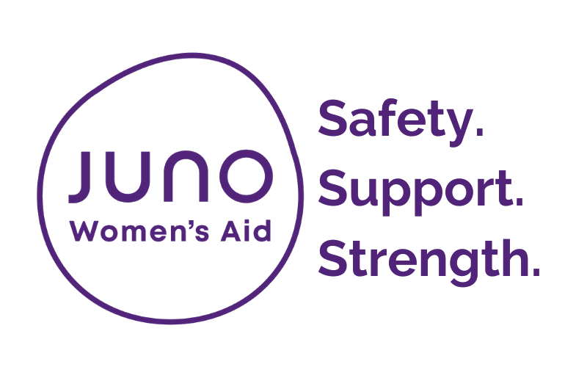
How to complete this referral:
By completing this referral form, you’re helping us to make contact with the woman as safely and quickly as possible. Please complete thoroughly as this saves the service user from being asked the same questions twice and helps us to understand more about their particular needs and circumstances.
If you have any queries regarding Zola refuge, please contact the Juno 24 hour helpline 0808 800 0340 or email helpline@junowwomensaid.org.uk

How to submit this referral:
To submit your referral via secure email please send to: helpline@junowwomensaid.org.uk

Supporting documentation (professionals only):
Please attach the following documents to this referral:
- DASH RIC - IF YOU ARE A PROFESSIONAL, YOU MUST SEND A CURRENT DASH RIC WITH YOUR REFERRAL AS WE ARE UNABLE TO PROCESS ANY REFERRALS WITHOUT THIS SUPPORTING INFORMATION
- any other risk assessments which are available
- IF YOU A WOMAN WHO IS SELF REFERRING TO A COUNTY SERVICE, THIS IS NOT REQUIRED

1. Information about the person making the referral
Date of referral:
Please enter your name and contact details:
Referrer’s name
Organisation name | Click here to enter text.
Role/ job title | Click here to enter text.
Contact number | Click here to enter text.
Contact email | Click here to enter text.
Consent:
Has the woman given consent to have the referral? |  | Yes ☐ No☐

2. Woman’s Contact Information
Names
First name | Click here to enter text.
Last name
Other names | Click here to enter text.
What do they like to be called? | Click here to enter text.
Date of Birth | Click here to enter text.
Addresses
Details Safe to contact?
Phone |  |  | ☐ to call ☐ to text  ☐ to leave voicemail
Email | Click here to enter text. |  | ☐
Current address  (inc. postcode) | Click here to enter text. |  | ☐ to post
Is this the address the address the woman is fleeing from ? | ☐ Yes ☐ No ☐ Don’t Know
Does the perpetrator live at this address?  If no, is he aware of the woman’s address? | ☐ Yes ☐ No ☐ Don’t Know  ☐ Yes ☐ No ☐ Don’t Know
Areas unable to go to due to safety
Safe contact notes (including safe contact times for example) | Click here to enter text.
Access requirements
Does this woman have any access requirements (for example, braille documents) | ☐ Yes  ☐ No  ☐ Don’t Know | If yes, please provide details:  Click here to enter text.
Does this woman require an interpreter? | ☐ Yes  ☐ No  ☐ Don’t Know | If yes, please provide details:  Click here to enter text.

Financial information
☐ Working Part time
☐ Working Full time
☐ Currently on benefits
☐ Eligible but not accessing benefits
☐ No Recourse to Public Funds

Further information about income

- Equalities monitoring
How would this service user  define their gender? | ☐ Female  ☐ Male  Other (please specify): Click here to enter text.  ☐ Don’t Know
Is their current gender different to the gender they were assigned at birth? | ☐ Yes  ☐ No  ☐ Don’t Know
The 2010 Equality Act defines disability as ‘a physical or mental impairment which has a substantial and long term adverse [negative] effect on their ability to carry out normal day to day activities’
Based on the definition above, do they consider themselves to have any kind of disability?  (please tick any that apply) | ☐ Physical  ☐ Learning  ☐ Mental Health |  | ☐ Deaf/ hearing impaired  ☐ Blind/ visually impaired  Other (please specify):  Click here to enter text.  ☐ Don’t Know
How would they describe their ethnicity?
☐ White British  ☐ White Irish  ☐ White Gypsy or Irish Traveller  ☐ Any other White background  ☐ Asian British  ☐ Asian Indian  ☐ Asian Pakistani  ☐ Asian Bangladeshi  ☐ Any other Asian background  ☐ Chinese  ☐ Arab |  | ☐ White and Black Caribbean  ☐ White and Black African  ☐ White and Asian  ☐ Any other mixed/ multiple background  ☐ Black British  ☐ Black African  ☐ Black Caribbean  ☐ Any other Black background  Other (please specify):  Click here to enter text.  ☐ Don’t Know
Do they have a faith/ religion?
☐ No religion  ☐ Bahai  ☐ Buddhist  ☐ Christian  ☐ Hindu  ☐ Jewish  ☐ Jain |  | ☐ Muslim  ☐ Shinto  ☐ Sikh  ☐ Zoroastrian  Other (please specify):  Click here to enter text.  ☐ Don’t Know
What is their sexual orientation? | ☐ Heterosexual/ straight  ☐ Gay woman/ Lesbian  ☐ Bisexual  Other (please specify): Click here to enter text.  ☐ Don’t Know
Do you require access to services specific for cultural or religious needs: Yes/No

Please state:

- Woman’s support needs/ vulnerabilities
Please tell us more about any support needs the woman may have:
☐ Mental Health  ☐ Physical Health  ☐ Sexual Health  ☐ Substance misuse |  | ☐ Aggressive behaviour/ violent tendancies  ☐ Self-harming/ suicidal feelings  ☐ Offending  Other (please specify below)
Click here to enter text.
Is the survivor currently pregnant  Due date Click here to enter text. |  | ☐ Yes ☐ No ☐ Don’t Know
Are there any known risks to working with this woman?
Click here to enter text.
What is the woman’s nationality? | Click here to enter text.
(if not British National) What is her immigration status? | Click here to enter text.
(if not British National) Do they have access to Public Funds? | ☐ Yes ☐ No ☐ Don’t Know

5. Children
Please provide names and Date of Births for any children below:
Name | Date of Birth
Click here to enter text. | Click here to enter text.
Click here to enter text. | Click here to enter text.
Click here to enter text. | Click here to enter text.
Click here to enter text. | Click here to enter text.
Click here to enter text. | Click here to enter text.
Click here to enter text. | Click here to enter text.

Safeguarding

Please give details of any safeguarding issues include historical Social Care involvement, name of Social Worker and contact details:

Please provide details of any of the children with a disability or support needs

- Alleged Perpetrator/s
Please provide name/s and Date of Birth/s for alleged perpetrator/s below:
Name | Click here to enter text.
Relationship to woman | Click here to enter text.
Address | Click here to enter text.
Date of Birth | Click here to enter text.
If there is more than one alleged perpetrator, please provide additional details in the box below:
Click here to enter text.

7. Reason for referral
Why are you making this referral – how could this woman benefit from our support?
Click here to enter text.

☐ Safety Planning  ☐ Court or legal support  ☐ Children’s issues  ☐ Tenancy issues  ☐ Resettlement/sanctuary required |  | ☐ Support to moving to refuge  ☐ Money and debt  ☐ Immigration  ☐ Other (please specify): Click here to enter text.
Types of abuse
☐ Domestic abuse  ☐ Forced Marriage  ☐ Female Genital Mutilation | ☐ Honour Based Violence  ☐ Trafficking |  | ☐ Sexual exploitation  ☐ Other Please specify:
Referred for support around:
☐ Emotional/psychological  ☐ Financial | ☐ Physical  ☐ Sexual |  | ☐ Coercive control  ☐ Harassment/stalking
Please make sure you have attached the following:
☐ DASH RIC
☐ Other (please specify): Click here to enter text.

Thank you for taking the time to complete this referral.

